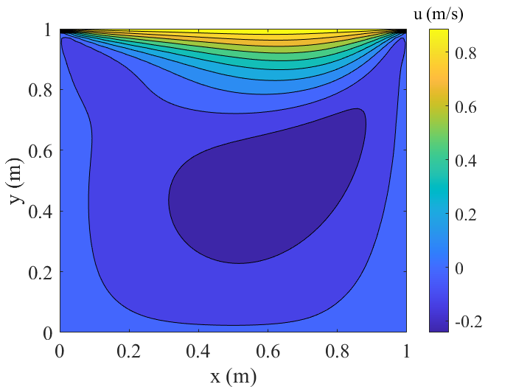CFD Final Project: Phase I

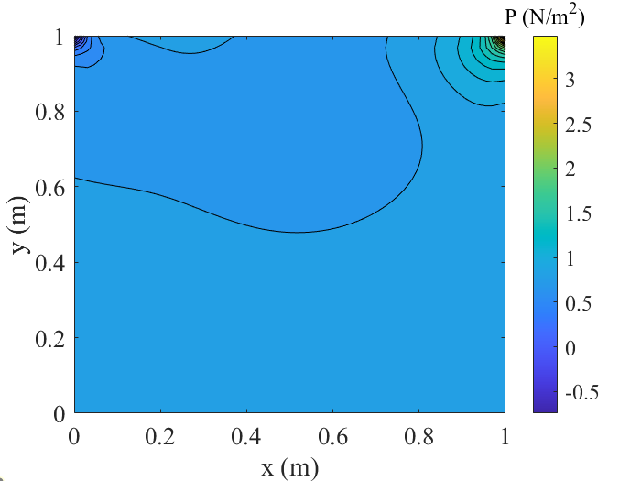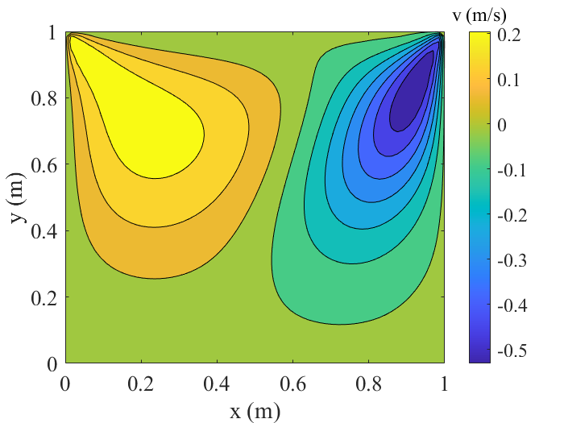

Figure 1. Steady-state plots of u, v and pressure for lid-driven cavity flow. 65x65 nodes used with SGS method.